
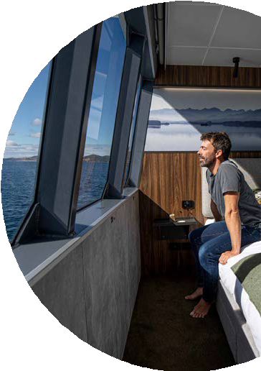
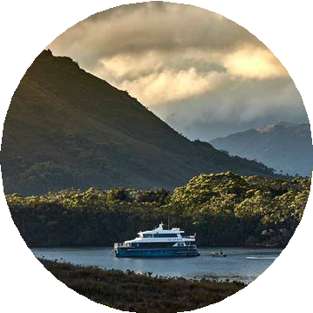
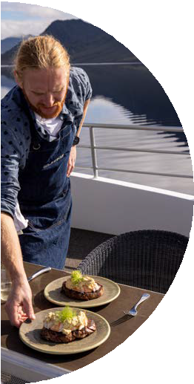
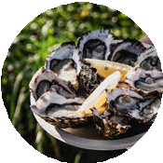
ON BOARD
Business with purpose

Conscious cruising in the remote corners of Tasmania’s World Heritage-listed wilderness
Sustainability is at the centre of On Board’s Odalisque III design. With just 12 guests, a minimal footprint is maintained when exploring, food miles are kept to a minimum and local produced and crafted elements feature across every aspect of the boat.
Expedition vessel Odalisque III was constructed in Hobart using 98% local materials and suppliers, including the Huon pine tables of the dining room, the soft local-made mattresses and the purpose-built adventure boats for exploring.
Tinted glass has been used throughout to help keep the cabin temperature stable. With large picture windows throughout the vessel, the tinted glass reduces the reliance on air conditioners on hot days and the overall requirement for energy production.
Odalisque III is fully self-contained, including black water holding tanks and associated procedures that fully comply with stringent Australian Maritime Safety Authority and Parks and Wildlife Service guidelines.
With a larger boat, comes a more sizeable demand for power. On Board has a large 920Ah lithium-ion battery bank installed in the hull of Odalisque III. This minimises the use of generators, ensuring they won’t be running overnight.
Through considered design, the experience has a low environmental impact and avoids the requirement for a land-based footprint.

Intimate, low-impact journeys
A small group size of just twelve guests ensures a small footprint on the sensitive wilderness areas On Board visits.
All guests are inducted by a team of expert guides into strong biosecurity practices which will include the checking of guests’ external clothing and footwear for soil and seed remains.
Head chef Toby Cannon and his team of culinary professionals are passionate about using only the freshest local ingredients. This keeps our food miles to a minimum.
100% of our produce is Tasmanian-grown or supplied locally and supports great relationships with island producers. Guests will sample Tasmanian pinots from family- run vineyards, and taste their way through four craft beers and ciders on tap before feasting on freshly-caught seafood. Food wastage is minimised through tailored menu planning, which takes into account dietaries and dislikes, and reuses leftovers.
All waste and recycling is taken back to Hobart for disposal at approved facilities and green waste is composted. Single-use plastic is avoided, with friendlier, compostable alternatives being used as much as possible in all areas of the vessel. Just 36sqm of plastic wrap were used in the 2022-23 season.
On Board is fully self-contained in all water production and use within the Tasmanian Wilderness World Heritage Area (TWWHA), with a water maker that converts salt water into freshwater. Rainwater collected on the roof of the vessel is saved as drinking water. From the pristine skies of the remote southwest, it’s some of the cleanest water in the world.

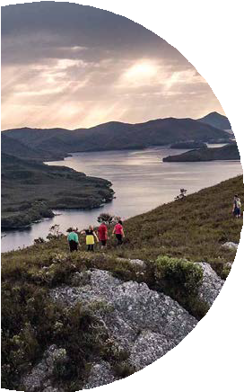
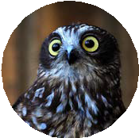
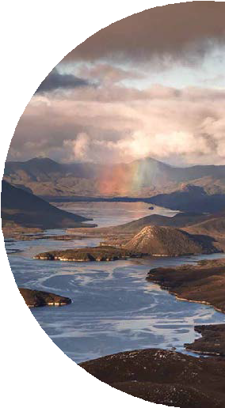
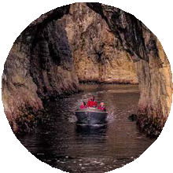
Conservation and care for the environment
Responsible tourism is core to their business design and innately connected with their purpose to inspire, educate and connect guests to a wilderness that they love. As part of any experience, guests are shown how to explore the wilderness with care, including by keeping to small group sizes and adhering to marked tracks. Expert guides educate guests on the values of the TWWHA and the significance of the area.
On Board partner with Raptor Refuge, which rehabilitate and protect Tasmanian raptors, helping raise awareness and to date have donated more than $10,000 towards this worthy cause. Responsible tourism is core to
On Board’s business design and innately connected with their purpose to inspire, educate and connect guests to Tasmania’s wilderness areas.
On Board has collaborated with Tasmanian botanical artist Deborah Wace to magnify and educate about threatened endemic plants. Two of Deborah’s special designs, ‘Giant Kelp Forest’ and ‘Lomatia tasmanica’, feature on soft linen cushions in our guest cabins.
Giant Australian Kelp (Macrocystis pyrifera) is a magnificent plant that can grow to 30 metres from the sea floor to the water’s surface, creating dense forests along the exposed coasts and deep water reefs of Tasmania. These giant forests support an incredible range of species and are at dire risk of extinction from the rising sea temperatures created by human-induced climate change.
Discovered by southwest Tasmanian pioneer Deny King, Lomatia tasmanica or King’s Holly is a critically endangered plant, surviving in just one location. There are thought to be only 500 plant stems clustered around
1.2 kilometres of rainforest gully, meaning one catastrophic bushfire could eradicate it forever.
Each custom-made piece of screen-printed linen is saturated with the warmth and richness of chartreuse greens, antique golds, seaweed pinks, lichen blues, burnt umbers and a myriad of other colours inspired by nature.
“With our expeditions designed to inspire a greater appreciation for the natural world, we aim to educate and excite our guests about conserving the wild places that we love for future generations.” says On Board founder Pieter van der Woude.

Honouring Aboriginal heritage
Learning of Tasmania’s Aboriginal cultural heritage forms a special part of the experience. Guests have the opportunity to visit sites in the area that evidence a long and unceded indigenous occupation, including cave and ochre sites. There is an Aboriginal interpretive walk that shares the story of the Needwonnee people of the southwest which guests will have the opportunity to do. Another of On Board’s signature experiences is the Stephens Bay beach walk, which takes guests to a significant Aboriginal cultural living site, including the site of a village estimated to be 7,000 years old.

Supporting our local community
More than 30 local artists’, producers’ and makers’ works are displayed on the vessel, including organic skincare by Milie Organics and exquisite hand-made sea-green crockery made by local potters Small Fires Studio. The onboard reference library is stacked with fiction and non-fiction works by local authors. The local flavour carries through to our crew, 100% of which are Tasmanian.

Threatened, endemic & invasive species: A citizen science project
To support the conservation of wildlife in Tasmania’s national parks, marine reserves and Wilderness World Heritage Area, On Board has partnered with the Department of Natural Resources and Environment Tasmania (NRE) on a citizen science project.
During the six-month Port Davey season, On Board surveys, records and reports sightings of target rare, threatened and migrating species, such as the ground parrots, hooded plover and water rat, as well as introduced species such as the Pacific oyster and long-spined sea urchin. In partnership with
the NRE, specific sites relevant to each species have been identified. For example, when visiting the Old and Davey Rivers on tender excursions, guests and crew monitor for the azure kingfisher. Guests are also involved in setting and reviewing animal activity recorded on motion detection cameras. Any opportunistic sightings by guests and our crew are also recorded, along with information such as the GPS location and a description.
Findings are ultimately reported to the Tasmanian Government’s Natural Values Atlas (NVA), a publicly available, authoritative repository of Tasmania’s natural values and provides valuable information to guide conservation actions.
In December 2023, crew and guests surveyed the foreshore near Schooner Cove, Port Davey to search for the feral Pacific Oyster. The group found and reported what was identified as the fourth Pacific Oyster ever to be located in the Port Davey Marine Reserve. As part of ongoing monitoring efforts, On Board will continue to survey identified hotspots.

Other sustainability initiatives (Our mandatories)
- A minimal footprint is maintained when exploring sensitive wilderness areas, with each aspect of the experience carefully planned
to reduce our impact, from energy usage to waste minimisation and disposal; energy-saving battery system; water creation and rainwater collection; provision of reusable water bottles to guests; recycling and composting processes; and use of eco-certified cleaning products. On Board are committed to constantly reviewing and refining our strategies.
- Locally produced, crafted and created elements feature across every aspect of the boat. On the tables, find exquisite custom-made ceramics handcrafted by a Hobart potter. On the beds, discover linen screen printed with endangered Tasmanian botanicals, and on the walls hangs artwork from celebrated local artists.

- Guests are educated as to the values, significance and importance of ongoing protection of the Tasmanian wilderness. All guests are inducted by expert guides and made

familiar with biosecurity practices to protect the fragile environment. To extend their learning, guests have access to a comprehensive onboard reference library and participate in citizen science projects.
- Food miles are kept to a minimum with locally produced and sustainably sourced produce featuring on a seasonal and tailored menu.
- On Board supports the conservation and rehabilitation of our wild places and wildlife through sponsorship of and fundraising for community groups and not-for-profits such as the Raptor Refuge, which rescues injured birds of prey and rehabilitates them for release back into the wild.
- On Board is dedicated to measuring, reducing and avoiding carbon emissions. They are a Sustainable Tourism Accredited Business, a certified member of the Tourism Emissions Reduction Commitment and have an Emissions Reduction Plan.

